Marketing Plan-Samsung Galaxy S8
Student’s name:
Institutional affiliation:

Marketing Plan-Samsung Galaxy S8
Table of Contents
1.0 Executive summary 4

2.0 Current Situation........................................................................................................................5 2.1 SWOT Analysis..........................................................................................................5-6 2.2 Competitors................................................................................................................6-7

3.0 Target Market Segmentation.....................................................................................................7
3.1 Market Summary.........................................................................................................7-8 3.2 Market demographics.................................................................................................8-9
4.0 Marketing Objectives...............................................................................................................9

5.0 Product Positioning..............................................................................................................9-10

6.0 Marketing Mix.........................................................................................................................10
6.1 Product Strategy.....................................................................................................10-11 6.2 Pricing Strategy............................................................................................................11 6.3 Marketing Communication.....................................................................................12-13
7.0 Implementation Plan...............................................................................................................13 7.1 Legal/Ethics............................................................................................................13-14 7.2 Contingency Plan....................................................................................................14-15 7.3 Measuring Marketing...................................................................................................15
8.0 Financial Projections and Implications....................................................................................16 8.1 Sales Forecast for the Samsung Galaxy S8..................................................................16 8.2 Break-even Analysis....................................................................................................17 8.3 Marketing Expense Budget for the Samsung Galaxy S8.............................................18
9.0 Overall Recommendation...................................................................................................18-19
Reference..................................................................................................................................20-23

1.0 Executive Summary

The study of a new product usually concentrates on the first steps of developing the product, the initial process of launching the marketing of the product and other possible activities aimed at making the product performance in the market efficient. As per Statista (2016), research, there are more than 207 million users of Smartphone in U.S only and over 2.5 billion users in the world. Samsung has been committed to improving a world through various technological innovations in Cell phone and electronics industry for more than 70 years. Samsung company headquarters is located at Suwon, South Korea. However, the company has spread its business with auxiliary assembling centers all over the world. The Samsung electronics is the leading company in manufacturing of digital technological electronics all over the world.
The marketing plan will dwell on Samsung Galaxy S8 across demographics in The United states. The marketing plan will incorporate the SWOT analysis of the product in both American market and the global market. Additionally, the plan will look into the appropriate marketing strategies, the target market, marketing objective, the correct positioning of the product in the market, the 4P marketing mix, best procedure to implement the marketing plan, the financial analysis of the plan and general performance of the product in the market. Lastly, there will be a contingency plan if changes are necessary. As you will see, this marketing plan will keep Samsung’s vision and values at the forefront and also ensure the marketing goals are met for a successful July 2018 launch of the improved product.

2.0 Current Situation

According to research by Smith, (2015) Samsung is the best Smartphone currently in the world market. Samsung is the leading manufacture in the market followed by Apple and Lg. Samsung Galaxy S8 phone usability is more efficient with best human interface feature compared to Apple iPhone 8 and LgG.

2.1 SWOT Analysis

This section will discuss the strengths, weakness, opportunities and threats of Samsung Galaxy S8.

Strengths
- The phone is light in weight so easy to carry.
- The slim edged Smartphone shape is very beautiful and attractive
- The phone OLED display resolution is very high thus gives clear bright view
- The phone bears protection marking that makes it water and dust resistant
- It has high security feature such as fingerprint scanner and Irish scanner

Weakness
- The phone is very frangible and can easily shutter into pieces in case it drops from very low points
- The Phone 3000 MAh power battery is very low for such a big phone which can perform many tasks.
- The phone is installed with junk software, which seems to be waste of space since many people don't use all the software.
- Some of the phone icons like fingerprint detector are not effective, they fail at some points.

Opportunities
- Samsung Galaxy S8 is very improved in terms of its design. It has 6.2 inch infinity display with smooth flat screen and slim body edge giving the user a beautiful view.
- The phone is very improved in its quality. The phone has very effective android processing version, 8 megapixels camera and 26 GB internal storage memory.
- Samsung Galaxy S8 durability is improved. The phone has security and protective features which make it dust and water proof.

Threats
- Samsung Galaxy S8 is facing serious threats on its security features. Apple iPhone 8 seems to offer the top effective security features such as Irish scanner.
- The other threat is the competition on similar technology being provided by Apple iPhone 8 and LgG at low price

Competitors
The main rivals for the Samsung Galaxy S8 are the Apple iPhones and LgG. The Apple company recently released the iPhone 10, which is in direct competition with the Galaxy S8 and 8+. Both companies share similarities with its product look and performance. However, the there is difference in these two products which rest much on the market competition on customers choices between either iOS Phone or the Android phone.

3.0 Target Market Segmentation
3.1 Market Summary

The essential focused on customers are the Millennial, and youthful grown-ups (ages 18 to 34). Millennial is one the biggest populace portions in the U.S., totaling around 77 million (Nielsen.com, 2014). Youthful customers are the biggest portion of smart phone clients. As per Nielsen.com, (2014) approximately eighty six percent of American citizens use smart phone in their daily activities. Smart phones are part of their daily life and there in a hurry gadget to make up for lost time with messages, get refreshes via web-based networking media systems and tweet about games recreations.

The Samsung company likewise target professional experts and entrepreneurs with a yearly family unit pay above $75,000. The Seat Exploration Center review discovered 85% of individuals living in families winning $75,000 or all the more every year claim a cell phone. These buyers require longer battery existence with their cell phones for persistent correspondences. Their bustling calendars won't enable time to continue reviving their telephones. Numerous purchasers drive or go all the time, and need to get to remote associations from various areas.

In America, the number of people using Smart phone will reach 55.8 million by the year 2018. Most cell phones are furnished with video and camera abilities. More youthful clients depend on their gadgets to get to interpersonal organizations to transfer photographs, post web journals and play amusements on the web. Youthful learners are the target clients in all over the world.

3.2 Market demographics

As indicated by Lella (2014), one out of five youthful population do the greater part of their research by Google, chat via massager and read online news using smart phones. The youth population influences the Cell phone market, and it is then basic for Samsung to known their inclinations and work with their erraticisms, and give them what they lean toward and require. They normally spend much of their time on social media. The youth also use their Smartphone as source of music for entertainment, and other times as personal computer. They require actually need their information kept confidential and be able to customize it any time.

Clients in America are very selective to the manufacturer of their gadgets. They would opt to pay extra more for a product manufactured by their preferred designer than buying any other similar product in the market which they fear it may lack some important details. From research, half of Smartphone users normally use their phones to Google perch or send emails. Afterwards they conduct research on online Map, 32.5% of interviewers claimed to use the Smartphone application. Another research showed 25% people had moved digital video viewing and twenty three percent today make distance communication using the Smartphone via email, whats app or Face book. Americans proclaimed that smart phone is part of their life. This the motivation behind why Apple phones rule in America. Apple company understands the psychology of American people especially on how they view and what feature motivates them in Smartphone. After noticing that, Samsung company have begun an act of removing the 'Galaxy' name from their products. This strategy actually promises Samsung good reap in American market in near future.
4.0 Marketing Objectives

• Year 1: Get broad media consideration and retail bolster in the primary year of propelling the new item. Accomplish 45,000,000 of unit deals toward the finish of the main year and increment mark mindfulness by 40% with the focused on group of onlookers.

• Year 2: Maintain a solid development each quarter (in spite of occasional deals examples) and achieve 47,700,000 in deals capacity

• in Third year: Accomplish relentless increment in display entrance in the 3rd year to fortify the market for Samsung company.

5.0 Product Positioning

To better position the Samsung Galaxy S8 to a great degree in Smartphone market, the organization will build up a better positioning statement which contains three fundamental components: an targeted interest group, an edge of reference, and a state of distinction. The youth are quick paced people who consider much on the looks and don't like reading too much on finer details and literature information about a gadget. They invest a lot of time on online social media so the new marketing strategy will include advertisement on all necessary social media platforms and contain strong display messages which are speaking to customers. Likewise, the illustration on quality and water protection will be exceptionally speaking to customers. Samsung company proposed a positioning statement which is : Samsung Galaxy S8

is smooth also, classy. Regardless of whether all outside or in the solace of your home, take this phone with its thin outline and water protection technology. An awesome Smartphone for youngsters!

6.0 Marketing Mix
Achieving success in a new product development for international markets means developing new products that compete worldwide and capable of leveraging and coordinating the creative competencies and resources of the firm (Mohammed, 2016). The steps in new product development are in Appendix B. While developing marketing tactics we will implement the stages of the new product life cycle. These stages can be found in Appendix C for reference.
6.1 Product Strategy

The positioning places Samsung Galaxy S8 in its own class in the Smartphone market. The Smartphone is one of its kinds with 8 pixel technology for quick and precise auto-center framework. The Quad HD Super AMOLED show gives a wide screen to gaming or viewing your most loved motion picture. It is water-safe, and it rapidly charges in only 30 minutes. Contrasted with iPhone, the new World telephone is a more slender gadget with a more extensive screen, speedier processor and has a superior quality determination. Despite the fact that Samsung gives a similar stockpiling limit, it offers an extra memory card space that extends up to 200 GB by means of microSD. Accordingly, World S8 is the better decision for buyers who require extra stockpiling.
Samsung Galaxy S8 bundling is intended to offer trendy like the youthful millennial. The crate, which opens like a book, includes a smooth beat up shading plan. Hyun Jee Lim, the maker of the new bundling plan, made a one of a kind bundle with a captivating knowledge from the minute the buyer associates with the telephone.
6.2 Pricing Strategy
This section entails setting the price of Samsung Galaxy S8. The price of Samsung Galaxy S8 should be determined with consideration the market prices of similar product from rival companies, Apple and LG. Samsung achieves more clients by launching the new Samsung Galaxy S8 Smartphone into the market with low cost compared to rival the iPhone.
Samsung cooperates with market big seller’s cooperation like eBay and Amazon when launching their products in the market. The sells company normally research on capability of the customers to purchase the Smartphone at a certain price (Mohammed, 2016). They normally use skimming to determine the price. But when a rival company releases the similar product, Samsung usually lowers the price of their product.
"Differential valuing is the procedure of pitching a similar item to various clients at various costs" (Mohammed, 2016). Samsung offers the Samsung Cosmic system S8 at both significant bearers yet offers diverse costs. In the event that clients pick Verizon, they can either pay a level rate of $792.00 or a month to month expense of $33.00. In any case, in the event that they pick AT&T, they can either pay a level rate of $794.00 or a month to month expense of $26.00. To separate their valuing methodology from others, Samsung expects clients to pick a dissemination outlet to monitor their purchasing history and area. Samsung's offering system is by offering dynamic evaluating with its new items.

6.3 Marketing Communication
It is imperative to pick the best possible method to convey the information particularly "with the ascent of computerized media, the coordination and joining of channels has turned out to be considerably all the more difficult" (Mohammed, 2016). It is additionally critical to choose a channel that will be compelling and broad. Relatives and other social channels, for example, companions or partners utilize verbal correspondence, which is persuasive as they can give proposals with regards to a purchasers' choice to buy (Omansky, 2012).
In the American market, it is essential to become acquainted with the way of life and their traditions. Utilizing the neighborhood assets in Japan would be exceptionally useful with choosing the favored showcasing channel. America has an extensive populace of buyers who utilize innovation with the goal that advanced interchanges might be the favored showcasing correspondence channel. Computerized interchanges incorporate sites, online group gatherings, and web-based social networking. The majority of these kinds of correspondences are buyer driven and will expect practically zero cash to promote. These customers are utilizing the innovation and can discuss their encounters to advertise the quality of the company.
More advanced communication on the product other than use of television and radio only are required. Numerous buyers in the U.S. showcase require visual showings or a well known representative to advance the item. This includes erecting a PowerPoint presentation in supermarkets and cities to advertise the Samsung Galaxy S8 Smartphone.
Interpersonal interaction media is the best other option to contact the a great many people. This channel is ceaselessly developing into bigger markets. Samsung can achieve a few global markets, at the same time to advance the new Samsung Galaxy S8 smart phone, speak with potential clients, offer rebates, and attract consideration regarding deals, all the more viably and proficiently.
7.0 Implementation Plan
The marketing plan was prepared to provide the Samsung Company with a good procedure to use in marketing Samsung Galaxy S8 Smartphone. The plan will help the company reach out the target customer population. Each step is important in executing the marketing plan. Each step shows the whole journey and should be meet by the responsible task force. The marketing process should make use of media adverts such as radio, television and print media posts. The media advertisements as form of marketing should be split into sections which will be aired at different times on television. Also, community partnership and sponsoring of some community activities like sports is one of best forms of marketing.
7.1 Legal/Ethics
Samsung must make sure not to offend consumers by taking advantage of defenseless groups or groups that are disadvantaged. The company should also ensure that their Smartphone has been rigorously tested and is safe for consumers and will not cause bodily harm. Product safety is critical. If a consumer was to be hurt by the Smartphone, Samsung could face legal liability that could result in stiff penalties and other legal costs and irrefutably tarnish their brand name.
In the international market, the company will need to research the culture and their customs adequately to ensure that they do not offend anyone. The countries laws and regulations need to be reviewed to guarantee that the company goes to market correctly and is not in violation of any revenue or tax codes. Finally, the company should confirm that all patents and copyrights for their technology have been legally obtained to avoid copyright and patent litigation.
7.2 Contingency Plan
A contingency planning is designed to identify possible challenges and vulnerabilities. Some potential challenges that Samsung may face are if another company, such as Apple, introduces a new smart phone model at approximately the same time, or the Galaxy S8 advertising campaign does not generate new sales or demand for the product. Also, Samsung’s change in branding strategy in the international market may not be well received.
If another company would introduce a comparable model at approximately the same time Samsung has built some cushion into its timeline so it can move the dispatch up if fundamental. Being first to enter the market will help Samsung in creating the buildup required for their item dispatch and will permit them not to be eclipsed by another organization.
On the off chance that the advanced media promoting effort does not create the business volume that Samsung is anticipating, they will assess the correspondence message, and the correspondence channels being utilized to pass on the message to guarantee that they are achieving their intended interest group with a message that reverberates. The organization will likewise have a moment or elective message prepared to dispatch if required and will have distinguished a few other channel alternatives too. This will enable Samsung to switch equips reasonably effectively.
The last piece of the alternate course of action will address Samsung's adjustment in marking system in the universal market. Samsung has expelled its name from the item and rebranded itself to bid better to purchasers in America and increase market share internationally. If the market share does not increase at an appropriate rate Samsung will increase communications in Japan and run a series of ads highlighting their transparency and their willingness to produce a product that conforms to the Japanese consumers specifications.
7.3 Measuring Marketing
The data collected during the marketing campaign will be used to decide whether every advertisement met its objectives and which promotions were best. We can gauge how the expanded deceivability in people in general eye impacts deals as an advertising design point of reference. The reaction to each immediate promoting strategy will be estimated and decided whether the developments were met. These measurements will be utilized to figure out which the web promoting advertisement pennants got the most snaps, which destinations created the most activity, and which materials had the most downloads. This information will decide whether the majority of our promoting objectives were met, to make the August 2016 dispatch of the Samsung World S8 a win.

8.0 Financial Projections and Implications
8.1 Sales Forecast for the Samsung Galaxy S8
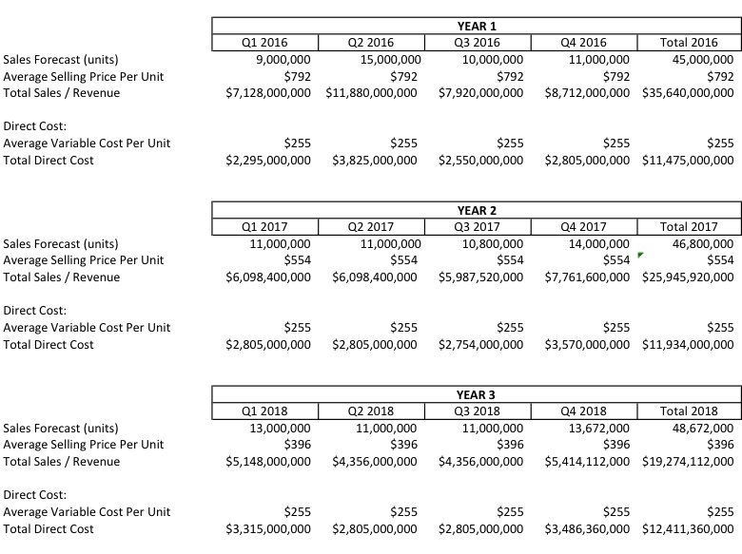
Total first-year revenue for the Samsung Galaxy S8 is projected at $35.6 Billion, which is based on sales of 45 Million units at an average selling price of $792. Samsung anticipates Q1 sales of $7 Billion, Q2 sales of $11.9 Billion, Q3 sales of $7.9 million, and Q4 sales of $8.7 Billion. The sales forecast assume higher unit sales because of the new product launch in Q1, substantial marketing budget and a rise in consumer sales in Q4 because of the holidays.
Samsung feels that sales will continue to increase over the next two years due to the strong demand of the Samsung Galaxy S8. The company is very conservative with its sales projection of only four percent increase in the second and third year.

8.2 Break-even Analysis

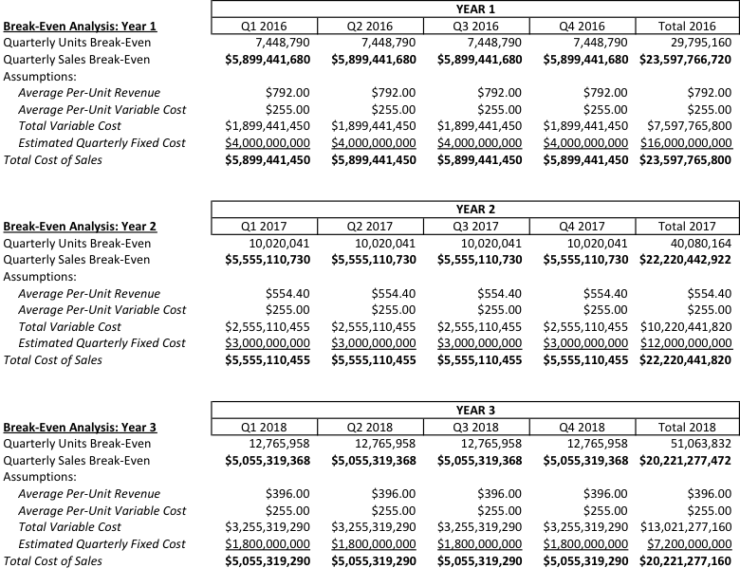
It shows that approximately $5.06 Billion in quarterly sales is needed in the first year to reach the break-even point. Strong demand for the Samsung Galaxy S8 will allow Samsung to reach the breakeven point in the first quarter of the first year. Once Samsung introduces the Samsung Galaxy S8, the company plans to slash the selling price of the Samsung Galaxy S8 by 30% in the second and 50% in the third year. This tactic is in line with the standard industry practice. As a new model is introduced, the price of the old model is reduced, and dramatically increases sales volume to cover the cost.

8.3 Marketing Expense Budget for the Samsung Galaxy S8

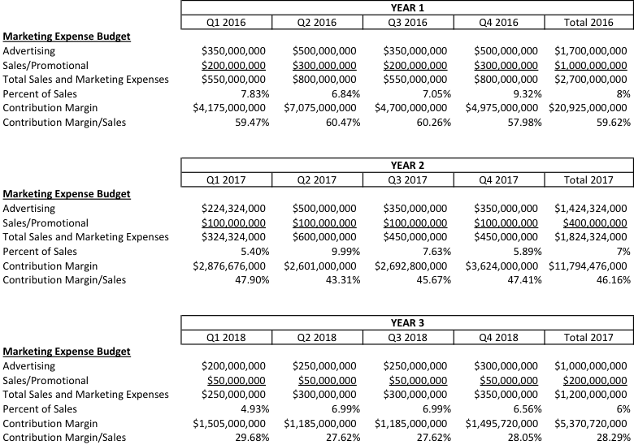

Samsung’s marketing expense budget includes advertising, social media communications, store displays, promotional sales, public relations, online marketing, sales training and customer-service support.
9.0 Overall Recommendation
In conclusion, the Samsung Galaxy S8 marketing plan is a great guide, for a successful August 2018 launch day. Team B was able to give the situation analysis, the marketing strategy, the marketing tactics, the financial projections, and the controls. Marketing plans are vital to the economic success of a product and can increase customer satisfaction.
Lastly, the presented marketing plan for Samsung Galaxy S8 is the best to be launched for successful performance of the product in global market. The marketing plans gives clear insights, marketing techniques, financial information and appropriate control measure for the product in the market. Marketing is very important aspect for success of the company and winning of customer loyalty.

Reference:
Calantone, R. J., Di Bendetto, C. A. & Song, M. (2011). Expecting Marketing Activities and
New Product Launch Execution to be Different in the US and China: An Empirical
Study. International Journal of China Marketing, 2(1), 1-32. Retrieved from
http://web.a.ebscohost.com.contentproxy.phoenix.edu/ehost/pdfviewer/pdfviewer?vid=3
&sid=6a0a0d63-fb60-4602-a3f0-153023fea813%40sessionmgr4001&hid=4112
De Brentani, U., & Kleinschmidt, E. J. (2004). Corporate Culture and Commitment: Impact on
Performance of International New Product Development Programs. The Journal of Product Innovation Management, 21, 309-333. Retrieved from http://web.a.ebscohost.com.contentproxy.phoenix.edu/ehost/pdfviewer/pdfviewer?sid=b8e818de-d8bd-4aac-ff517e44b354%40sessionmgr4001&vid=3&hid=4112
Davcik & Sharma. (2015). Impact of Product Differentiation, Marketing Investments and Brand
Equity on Pricing Strategies: A brand level investigation. European Journal of Marketing,
Vol. 49 Iss: 5/6. Retrieved from http://www.emeraldinsight.com.contentproxy.phoenix.edu/doi/full/10.1108/EJM-03-2014-0150
Danaher & Rossiter. (2011). Comparing Perceptions of Marketing Communication Channels.
European Journal of Marketing, 45. 1(2), 6-42. Retrieved from
http://search.proquest.com.contentproxy.phoenix.edu/docview/848012655/fulltext/9EF16
B6F8BDE4F93PQ/1?accountid=35812
eMarketer.com (2014). 2 Billion Consumers Worldwide to Get Smartphone by 2016. Retrieved
from http://www.emarketer.com/Article/2-Billion-Consumers-Worldwide-Smartphones-
by-2016/1011694#sthas.xvn8Cm3Y.dpuf
eMarketer.com (2016). Internet Users in Japan Shift Digital Behaviors to Mobile Retrieved from
http://www.emarketer.com/Article/Internet-Users-Japan-Shift-Digital-Behaviors-
Mobile/1013483
Buttle, F., & Groeger, L. (2014). Word-of-Mouth Marketing: Towards an Improved
Understanding of Multi-Generational Campaign Reach. European Journal of Marketing,
48(7/8). Retrieved from
http://www.emeraldinsight.com.contentproxy.phoenix.edu/doi/full/10.1108/EJM-02-
2012-0086
Hanks, Gerald; 2016. The Milestones in Marketing Plans. Chron: Small Business. Retrieved from http://smallbusiness.chron.com/milestones-marketing-plans-67234.html
Karakaya, F., & Kerin, R. A. (2007). Impact of Product Life Cycle Stages on Barriers to Entry.
Journal of Strategic Marketing, 15, 269-280. Retrieved from
http://web.a.ebscohost.com.contentproxy.phoenix.edu/ehost/pdfviewer/pdfviewer?sid=f3
421929-4574-427a-9356-3d1579d40c73%40sessionmgr4005&vid=3&hid=4112
Karjaluoto, H., Mustonen, N., and Ulkuniemi, P. (2015) ‘The role of digital channels in
industrial marketing communications’, Journal of Business & Industrial Marketing,
30(6), pp. 703–710. doi: 10.1108/jbim-04-2013-0092
Kiplinger, L. (2014). Millennials LOVE their smartphones: Deal with it. USA Today. Retrieved
from http://www.usatoday.com/story/money/personalfinance/2014/09/27/millennials-
love-smartphones-mobile-study/16192777/
Kotler & Keller. (2016). Marketing management. (15th edition), Upper Saddle River, NJ:
Pearson/Prentice Hall.
Lella, A. (2014). Why Are Millennials So Mobile? Retrieved from
https://www.comscore.com/ita/Insights/Blog/Why-Are-Millennials-So-Mobile
McCann, J. (2016, May 15). Samsung Galaxy S7 Review. Retrieved from
http://www.techradar.com/reviews/phones/mobile-phones/samsung-galaxy-s7-
1315188/review/8
Mohammed, R. (2016). Differential Pricing. Pricing for Profit. Retrieved from
http://www.pricingforprofit.com/pricing-explained/differential-pricing.php
Nielsen. (2015). Mobile Millennials: Over 85% of Generation Y Owns Smartphones. Retrieved
From http://www.nielsen.com/us/en/insights/news/2014/mobile-millennials-over-85-
percent-of-generation-y-owns-smartphones.html
Norazah, M.S. (2013) Students’ Dependence on Smart Phones: The Influence of Social Needs,
Social Influences and Convenience. Campus-Wide Information Systems, Vol. 30 Iss: 2,
pp.124 – 134. Retrieved from
http://www.emeraldinsight.com.contentproxy.phoenix.edu/
doi/full/10.1108/10650741311306309
Omansky, M. L. (2012). Positioning product for success. International Journal of Management
and Administrative Sciences, 1(5), 20-22. Retrieved from
http://search.proquest.com/docview/1327869162?accountid=458
Park, J.H., MacLachlan, D.L.& Love, E. (2016). New Product Pricing Strategy Under Customer
Asymmetric Anchoring. International Journal of Research in Marketing. Retrieved from
http://www.sciencedirect.com.contentproxy.phoenix.edu/science/article/pii/S0167811611
Samsung (1995-2016). Samsung Galaxy S7 edge, 32GB, (Verizon), Gold Platinum. Retrieved
from http://www.samsung.com/us/mobile/cell-phones/SM-G935VZDAVZW
Samsung (1995-2016). Welcome to Samsung. Retrieved from
http://www.samsung.com/us/aboutsamsung/
Smith, A. (2015). U.S. Smartphone Use in 2015. Retrieved from
http://www.pewinternet.org/2015/04/01/us-smartphone-use-in-2015/
Statista.com (2016). Number of Smartphone Users in Japan from 2013 to 2019.
Retrieved from http://www.statista.com/statistics/275099/number-of-smartphone-users-in-japan/
Weise, E. (2015). Smartphones Reaching Saturation Among Millennials. Retrieved from
http://www.usatoday.com/story/tech/2015/10/29/smartphones-saturation-millennials-
pew-research/74805506/
Williams, Oneil; 2016. What Are Communication Channels Within an Organization? Chron,
Small Business. Retrieved from http://smallbusiness.chron.com/communication-
channels-within-organization-61447.html
Wrigley, F. (2014). Japan’s Biggest Online Retailers now Have More Smartphone Traffic than
Desktop Site Users. Retrieved from http://en.rocketnews24.com/2014/12/19/japans-
biggest-online-retailers-now-have-more-smartphone-traffic-than-desktop-site-users/

